This lab is a perfect practical application of Requirements Engineering, a skill you've been honing through your work on Agentic AI workflows and AWS Data Architecture. Organizing unstructured stakeholder "wishes" into a structured Affinity Chart is the first step in moving from a conversation to a technical specification.
Based on the interview excerpts from Fleet Ease Logistics, here is the categorization and grouping for your lab submission.

Part 1: Requirement Identification & Classification
To complete Step 4 of your lab, here are three requirements for each of the four core categories:

1. Business Requirements (The "Why")
These define the high-level goals and desired outcomes for the organization.
- Real-time Inventory Visibility: Provide a single view of all pallets and SKUs to eliminate the current multi-hour update delay.
- Operational Efficiency: Reduce manual data entry errors by 30% through automated validation and scanning.
- Financial Transparency: Generate monthly exportable reports on inventory turnover and aging stock to satisfy CFO requirements.

2. Functional Requirements (The "What")
These describe the specific behaviors and features the system must have.
- Automated Alerts: The system must flag duplicate or incorrect bin entries automatically.
- Reorder Notifications: The system must trigger an automated alert when stock levels hit a predefined minimum threshold.
- Supplier Portal: Provide an external-facing interface where suppliers can view and confirm orders directly.

3. Non-Functional Requirements (The "How")
These define the quality attributes and constraints of the system.
- System Latency (Performance): Inventory updates must reflect across the system within 5 seconds, even during peak multi-user usage.
- System Integration: The new platform must integrate seamlessly with existing ERP and procurement software without data loss.
- Security/Access: Implement role-based access control (RBAC) to ensure only authorized personnel can modify stock levels.

4. Transition Requirements (The "Bridge")
These are temporary requirements needed to move from the old system to the new one.
- Data Migration: Successfully migrate and validate five years of historical inventory data from the legacy system.
- Parallel Running: Maintain a "dual-run" overlap period where both the old and new systems are active to ensure stability before final cutover.
- User Testing: Conduct comprehensive data validation and User Acceptance Testing (UAT) before the official go-live date.

Part 2: Affinity Charting Strategy
When you move these into your Excel Affinity Chart Template, try clustering them by Natural Relationships rather than just their category. This helps in project planning.
Suggested Clusters for your Excel Template:
- Cluster A: Warehouse Execution (Real-time tracking, Barcode scanning, Bin alerts).
- Cluster B: External Collaboration (Supplier portal, Order confirmations).
- Cluster C: Technical Infrastructure (ERP integration, System speed, Role-based access).
- Cluster D: Implementation & Risk (Data migration, Dual-run overlap, UAT).

Venkatesh's Professional Edge:
In your Selenium Testing Platform, these requirements would serve as your "Test Basis." For example:
- Functional Requirement #6 (Reorder Notifications) would become a Functional Test Case.
- Non-Functional Requirement #10 (5-second updates) would become a Performance/Load Test.
Great. Moving into Adaptive (Agile) Project Management is a significant shift, especially if you are used to the structured "Sign-off then Build" approach of Waterfall.
In an Agile environment, the focus shifts from Documentation to Working Software and from Rigid Planning to Continuous Feedback. For a professional working on Generative AI Agents, this is often the most natural way to work, as it allows you to test a model's output, adjust the prompt, and iterate immediately.
Here is your Agile Transition Cheat Sheet to help you prepare for the next lesson:

1. The Core Mindset Shift
- Waterfall: "Plan the work, then work the plan." (Fixed scope, variable time/cost).
- Agile: "Build, Measure, Learn." (Fixed time/cost, variable scope).

2. Key Agile Roles (The Scrum Team)
- Product Owner (PO): Represents the business/customer. They decide what gets built by managing the Product Backlog.
- Scrum Master: The "Servant Leader." They don't manage the team; they remove obstacles (blockers) and ensure the team follows Agile principles.
- The Team (Non-PMs): Cross-functional experts (Devs, Testers, Analysts) who decide how to build the work.
- 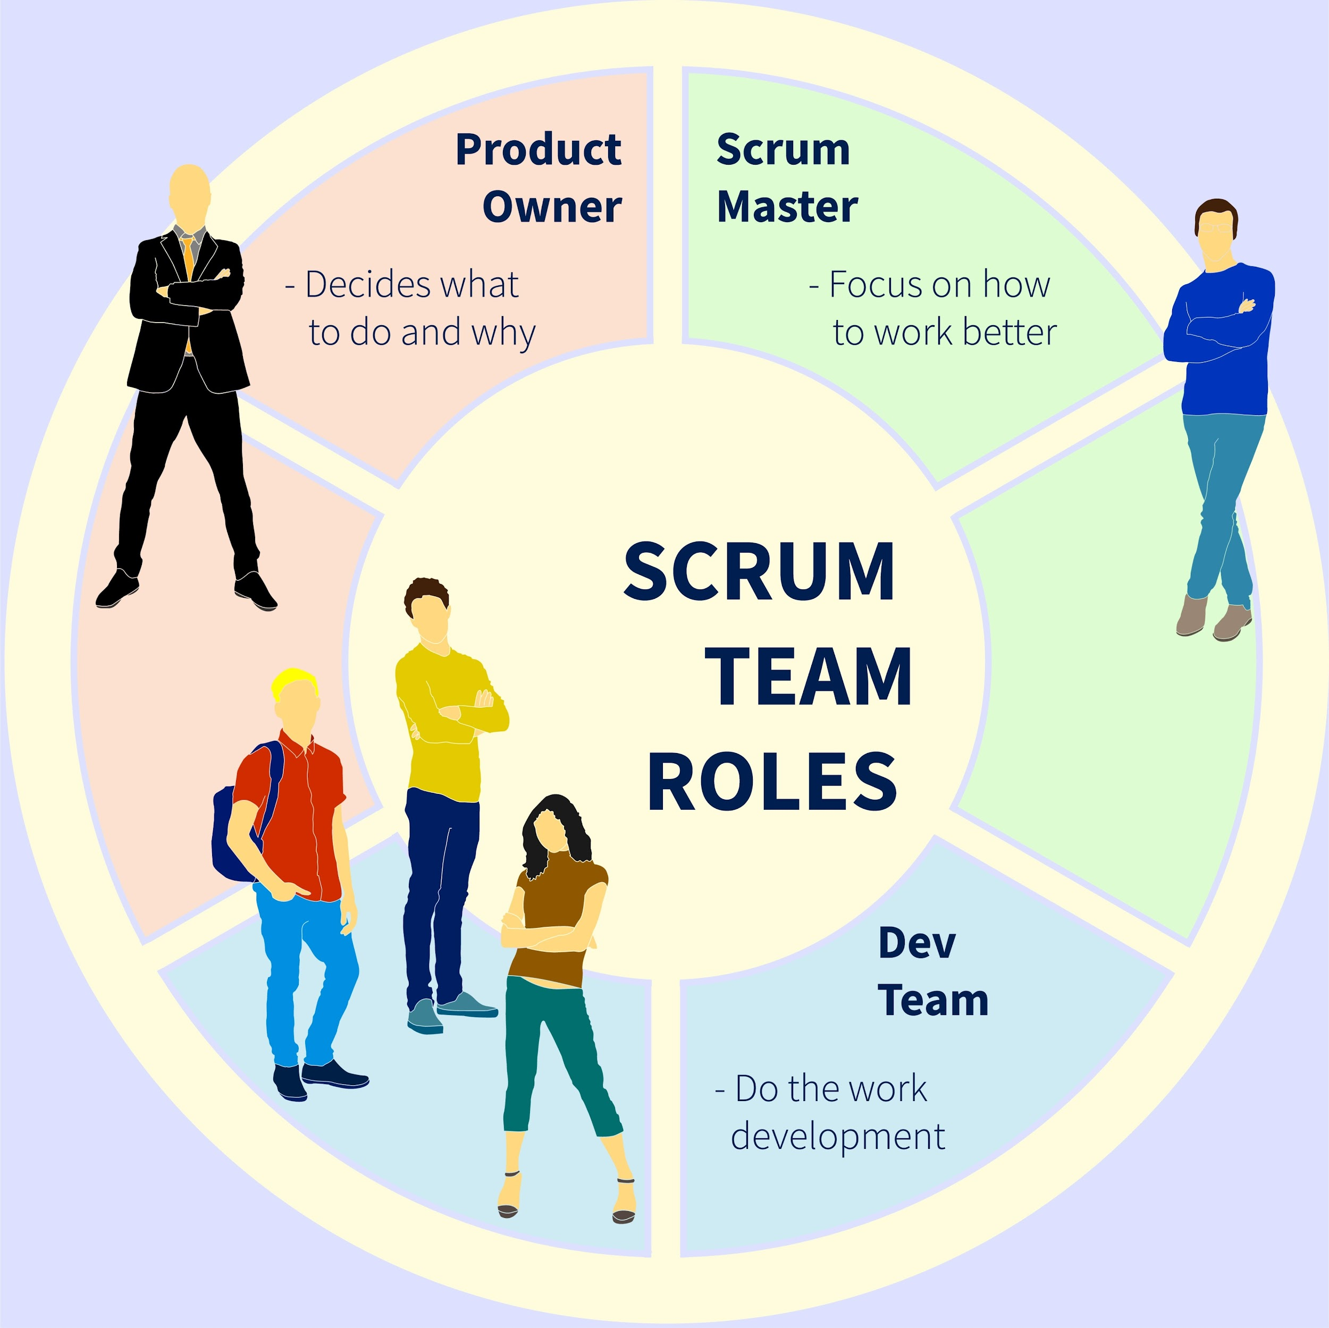
- Shutterstock

3. Agile "Events" (The Heartbeat)
- The Sprint: A fixed time-box (usually 1–4 weeks) where a "Done," usable increment is created.
- Sprint Planning: The team picks items from the Backlog to complete during the Sprint.
- Daily Stand-up: A 15-minute sync. What did I do? What will I do? Are there any blockers?
- Sprint Review: Demonstrating the finished work to stakeholders for feedback.
- Sprint Retrospective: The team looks inward—how can we work better in the next Sprint?

4. Agile Artifacts (Replacing the RTM)
- Product Backlog: A prioritized list of everything that might be needed in the product.
- Sprint Backlog: The specific subset of items the team is working on right now.
- User Stories: Requirements written from the user's perspective: "As a [user], I want [action] so that [benefit]."
- Burndown Chart: A visual tool showing how much work is left versus time remaining in the Sprint.

Venkatesh's Professional Application:
If you applied this to your Zenith Finance Tracker:
- Sprint 1: "As a user, I want to upload a CSV so I can see my spending."
- Sprint 2: "As a user, I want a pie chart of my expenses so I can visualize my habits."
You wouldn't wait to build the whole app; you would deliver the "Upload" feature first and get feedback immediately.

